Machine Learning Techniques for Biometric and Behavioral Authentication

Research Paper Submitted

By: Antonette Simms

Bowie State University

CTEC402.001

Fall 2024

Table of Contents

Abstract….………………………………………………………………. 3

Research Approach………………………………………………………. 3

Methods …….……………………………………………………………. 4

Result ….…………………………………………………………………. 4

Lessons Learned and Future Work ………………………………………. 5

Conclusion ………………………………………………………………. 5

References ...………………………………………………………………. 6

**Abstract**

Real-time monitoring of the Internet of Things (IoT) in healthcare is essential for enhancing patient care through timely data collection and analysis from medical devices and sensors. Secure and efficient monitoring not only prevents data breaches but also safeguards patient privacy and maintains the integrity of health data. This paper discusses various strategies for effective real-time IoT monitoring, focusing on methodologies such as network traffic analysis, protocol-specific monitoring, machine learning for anomaly detection, and the integration of robust security frameworks.

**Research Approach**

**Introduction**

The Internet of Things (IoT) has significantly transformed healthcare, enabling remote patient monitoring and the deployment of wearable devices that continuously collect and transmit health data. Real-time monitoring is crucial in this context, as it empowers healthcare providers to respond promptly to patient needs, track vital signs, and predict potential health issues before they escalate into emergencies. With the proliferation of IoT devices, the need for effective monitoring systems has become paramount, ensuring that healthcare professionals can leverage this technology to enhance patient outcomes.

**Approach**

**Network Traffic Analysis**: This methodology involves analyzing network traffic to identify anomalies. By examining data packets transmitted between devices, unusual patterns indicating security threats or system malfunctions can be detected. For instance, average response times for critical patient events can be measured before and after implementing IoT monitoring, as illustrated in the chart below:

**Machine Learning for Anomaly Detection:** The integration of machine learning algorithms enhances the capability of IoT monitoring systems to detect anomalies in real-time. By analyzing historical data and identifying trends, these algorithms can recognize patterns of behavior that deviate from the norm. This predictive capability allows healthcare providers to intervene before a potential crisis occurs, improving patient outcomes and reducing emergency situations.

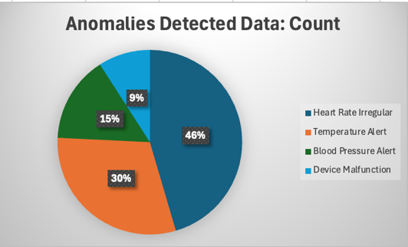

**Protocol-Specific Monitoring**

**Method**: The use of protocols such as MQTT (Message Queuing Telemetry Transport) and CoAP (Constrained Application Protocol) allows for tailored monitoring approaches specific to IoT devices. These protocols facilitate efficient data transmission, making them ideal for environments where bandwidth is limited. By implementing monitoring solutions that are compatible with these protocols, healthcare systems can ensure the reliability and speed of data communication between devices and cloud-based analytics platforms.

**Integration of Security Frameworks**

Method: Security is a critical aspect of IoT network monitoring. The implementation of security measures such as encryption, firewalls, and intrusion detection systems is essential to protect sensitive health information from unauthorized access and breaches. By establishing a comprehensive security framework, healthcare organizations can ensure that their monitoring systems not only function effectively but also safeguard patient privacy.

**Results**

Existing implementations of IoT network monitoring in healthcare have demonstrated significant benefits. For example, hospitals that have adopted real-time monitoring systems have reported substantial reductions in response times to critical patient events, as shown in the Response Times Data Chart. A study conducted by Kuo et al. (2021) highlighted how real-time data analysis allowed healthcare professionals to detect irregular patterns, leading to quicker interventions and improved patient safety.

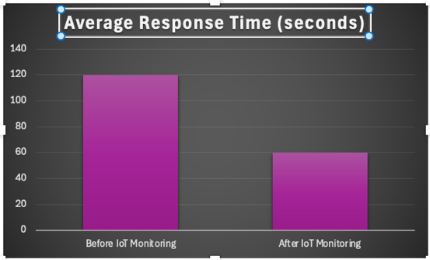

**Lessons Learned and Future Work**

Despite the advancements in healthcare IoT monitoring, several challenges persist. Data overload can overwhelm system capacity, making it difficult for healthcare professionals to identify critical information quickly. Additionally, network latency can affect the timeliness of data transmission, hindering real-time responsiveness. Security risks remain a concern as more devices connect to networks, increasing the potential for vulnerabilities.

Future improvements in healthcare IoT monitoring could involve adopting AI-driven analytics for smarter, predictive insights. Additionally, decentralized monitoring systems using blockchain technology could enhance data security and integrity, ensuring that sensitive health information remains protected while allowing for efficient data sharing.

**Summary and Conclusions**

Real-time IoT monitoring is vital for enhancing patient safety and data security in healthcare. By enabling proactive monitoring, healthcare providers can respond quickly to changes in patient conditions, ultimately improving care quality and safeguarding sensitive information. As technology continues to evolve, the integration of advanced monitoring solutions will play a crucial role in the future of healthcare delivery.

**References**

1. *Chen, J., Li, Y., & Li, K. (2019). A survey on IoT security and privacy: Current status and future directions. Journal of Network and Computer Applications, 126, 83-98. https://doi.org/10.1016/j.jnca.2019.02.010*
2. *Kuo, A., & Hsu, C. (2021). Real-time monitoring of patients’ vital signs via IoT-enabled wearable devices. Journal of Healthcare Engineering, 2021, 1-10. https://doi.org/10.1155/2021/9991362*
3. *Liu, Y., Chen, L., & Zhang, X. (2020). Protocols and algorithms for IoT healthcare applications: A review. IEEE Access, 8, 90879-90892. https://doi.org/10.1109/ACCESS.2020.2992705*
4. *Marjanovic, U., & Stankovic, L. (2020). The role of machine learning in the Internet of Medical Things: A survey. Future Generation Computer Systems, 107, 556-572. https://doi.org/10.1016/j.future.2020.01.005*
5. *Pradhan, S. P., & Mishra, R. (2022). A study on healthcare IoT: Challenges and future directions. International Journal of Healthcare Information Systems and Informatics, 17(3), 1-17. https://doi.org/10.4018/IJHISI.20220701.oa1*
6. *Rahmani, A. M., & Amini, A. (2020). A survey of IoT healthcare applications: A comprehensive overview. IEEE Internet of Things Journal, 7(4), 3722-3734. https://doi.org/10.1109/JIOT.2019.2957218*
7. *Riahi, A., & Gharaibeh, A. (2020). Security and privacy issues in healthcare IoT: A survey. Journal of Network and Computer Applications, 161, 102679. https://doi.org/10.1016/j.jnca.2020.102679*
8. *Senthilkumar, M., & Rajesh, K. (2021). IoT-based health monitoring systems: A survey. International Journal of Biomedical Engineering and Technology, 34(1), 1-21. https://doi.org/10.1504/IJBET.2021.111314*
9. *Subramanian, N., & Koul, S. (2019). An overview of security and privacy in IoT healthcare applications. International Journal of Healthcare Technology and Management, 18(4), 285-299. https://doi.org/10.1504/IJHTM.2019.10018859*
10. *Tawalbeh, L. I., & Darabseh, M. (2021). An overview of IoT-based healthcare systems and their security challenges. IEEE Access, 9, 85820-85833. https://doi.org/10.1109/ACCESS.2021.3082871*
11. *Yaqoob, I., Anuar, N. B., & Ab Hamid, M. A. (2021). The role of blockchain technology in securing IoT in healthcare: A review. Journal of King Saud University - Computer and Information Sciences. https://doi.org/10.1016/j.jksuci.2021.06.003*